Mini Project

*Topic: Online banking system using PHP*

Done by

Name: **BALAMURUGAN.G**

Roll no: **18E1741**

Reg no: **1813101058209**

Dept: **BCS.CS**

Year & sec**: 3-B**

Abstract:

Online Banking is one of the most important financial activities which will be carried out by any person who holds a bank account. Once a user logs in he or she can check the bank balance, check bank account transaction history or account summary, add beneficiary accounts, transfer funds to another account, loan information. Whenever we deal with a banking system main concern should be the security related to banking transactions and account login activity. In the existing system the transactions are done only manually but in the proposed system all the transactions are done through online banking system.

Language used:

Frontend:HTML, CSS, BOOTSTRAP, JAVASCRIPT

Backend:PHP & MYSQL

Screenshots:

HOME PAGE:



CUSTOMER LOGIN:

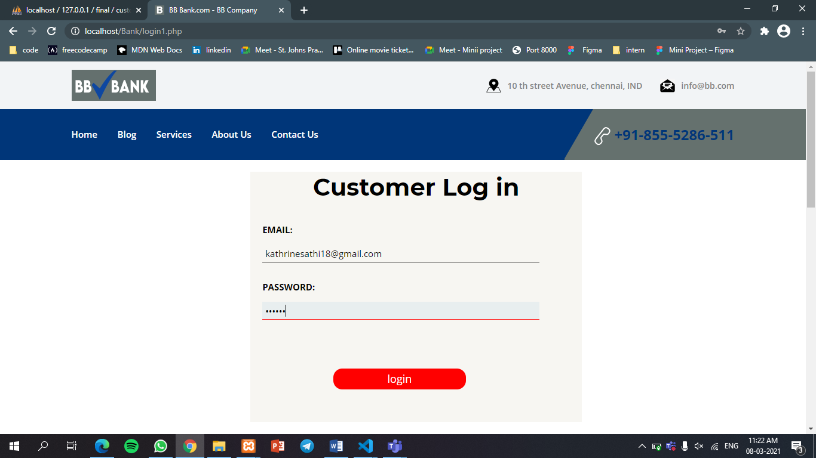

DASHBOARD:

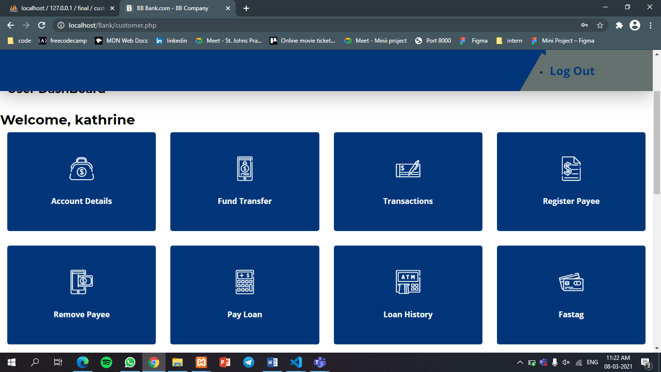

ADMIN LOGIN:

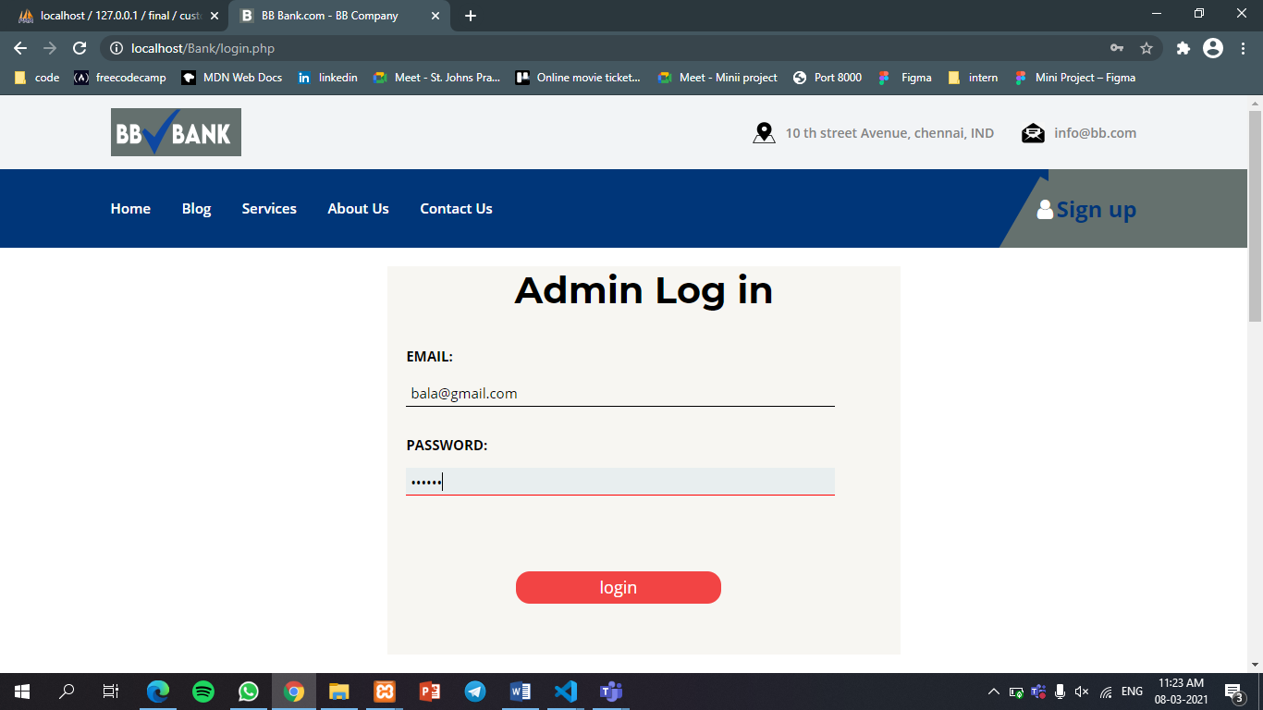

DASHBOARD:

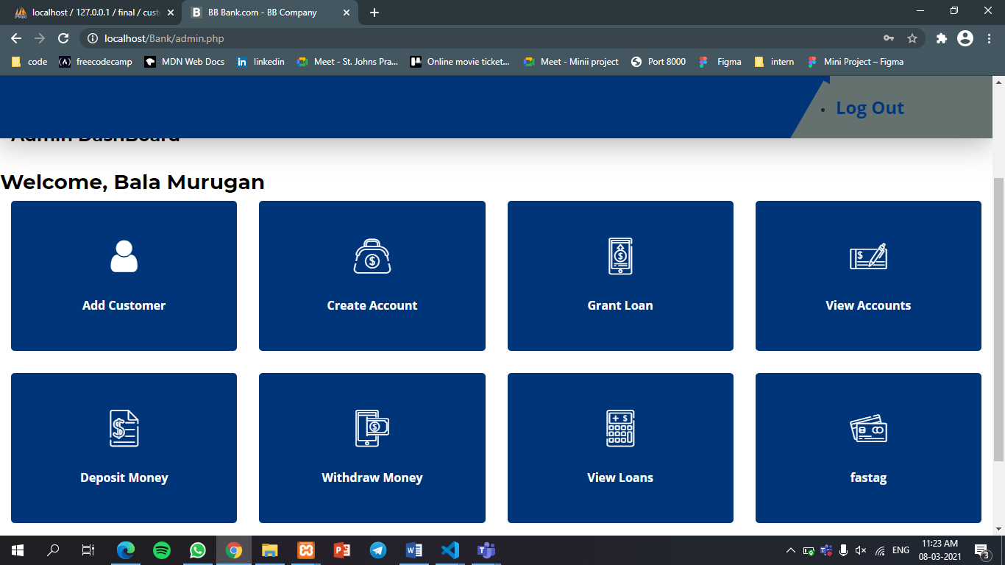

MYSQL DATABASE:

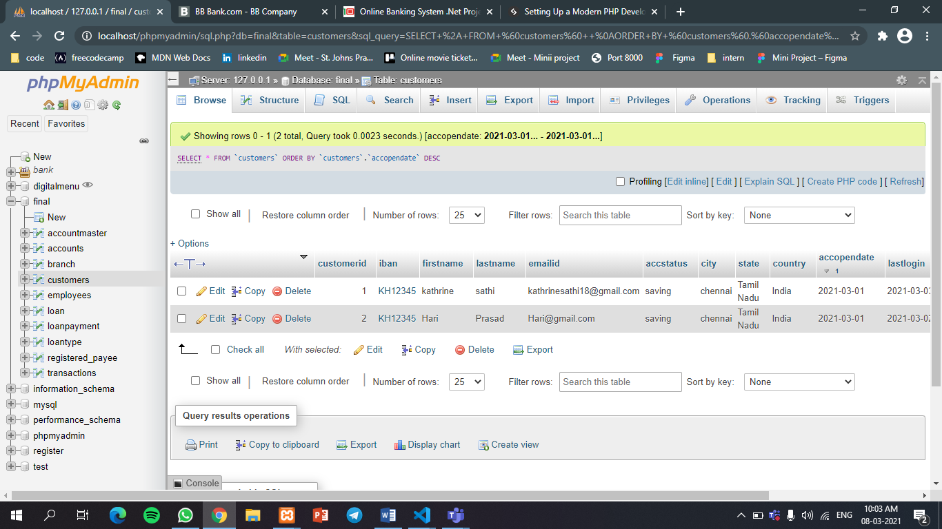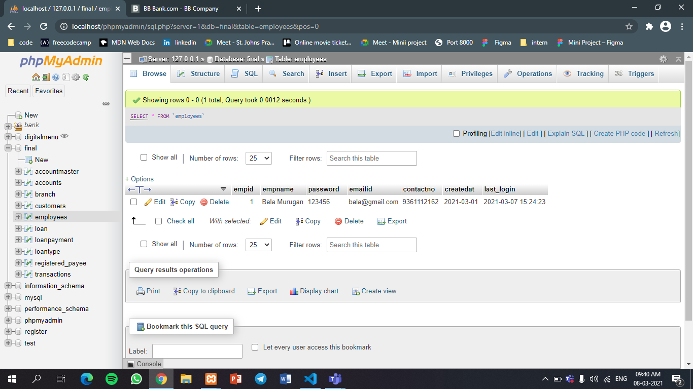

The main objective of the proposed Online banking system project is to be automated the various activities and functions of any bank through Internet. Online banking system project will facilitate to the bank employees and the customers with the different modules. Using the project the bankers and customers can generate various kinds of reports. The banking industry will take a big leap, shape and explore like never before.

* **Online banking system** will manage large number of bank transactions with ease.
* Online banking system will manage all details of the existing customers who are registered and allow them to operate their account online via internet.
* Online banking system project will provide facility to open new customer account and maintain its data efficiently and effectively.
* This project will allow bank admin to view all the details of the existing customer.
* Use of the proposed project will make activities like updating, modification, deletion of records easier as compared to the manual process.